Week #6 Assignment – Satish Ramachandran

# Problem #1

'''

Week6 - Problem #1

2D Convolution example

'''

from scipy import signal as sg

import tensorflow as tf

'''

Convolution using SciPy

'''

def convolution_scipy():

image = [[97, 52, 99, 62, 69, 45, 70],

[99, 14, 60, 50, 74, 45, 22],

[59, 72, 74, 14, 74, 100, 28],

[28, 8, 47, 85, 2, 88, 77],

[74, 6, 30, 87, 49, 22, 43],

[86, 87, 4, 53, 36, 10, 46],

[54, 7, 67, 23, 29,26, 15]]

gaussian_filter = [[1, 2, 1],

[2, 4, 2],

[1, 2, 1]]

conv_full_result = sg.convolve(image, gaussian_filter)

conv_valid_result = sg.convolve(image, gaussian_filter,"valid")

print("Full Convolution result:")

print(conv_full_result)

print("Valid Convolution result:")

print(conv_valid_result)

'''

Convolution usinf Tensorflow

'''

def convolution_tf():

image_list_tf = tf.constant([[97., 52., 99., 62., 69., 45., 70.],

[99., 14., 60., 50., 74., 45., 22.],

[59., 72., 74., 14., 74., 100., 28.],

[28., 8., 47., 85., 2., 88., 77.],

[74., 6., 30., 87., 49., 22., 43.],

[86., 87., 4., 53., 36., 10., 46.],

[54., 7., 67., 23., 29., 26., 15.]])

gaussian_filter_list_tf = tf.constant([[1., 2., 1.],

[2., 4., 2.],

[1., 2., 1.]])

image_tf = tf.reshape(image_list_tf, [1,7,7,1])

gaussian_filter_tf = tf.reshape(gaussian_filter_list_tf, [3, 3, 1, 1])

conv_full_result = tf.nn.conv2d(image_tf, gaussian_filter_tf, strides=[1,1,1,1], padding='SAME')

conv_valid_result = tf.nn.conv2d(image_tf, gaussian_filter_tf, strides=[1,1,1,1], padding='VALID')

with tf.Session() as sess:

print(conv_full_result.eval())

print(conv_valid_result.eval())

convolution_scipy()

convolution_tf()

The output from both SciPy and Tensorflow are the same as seen below:

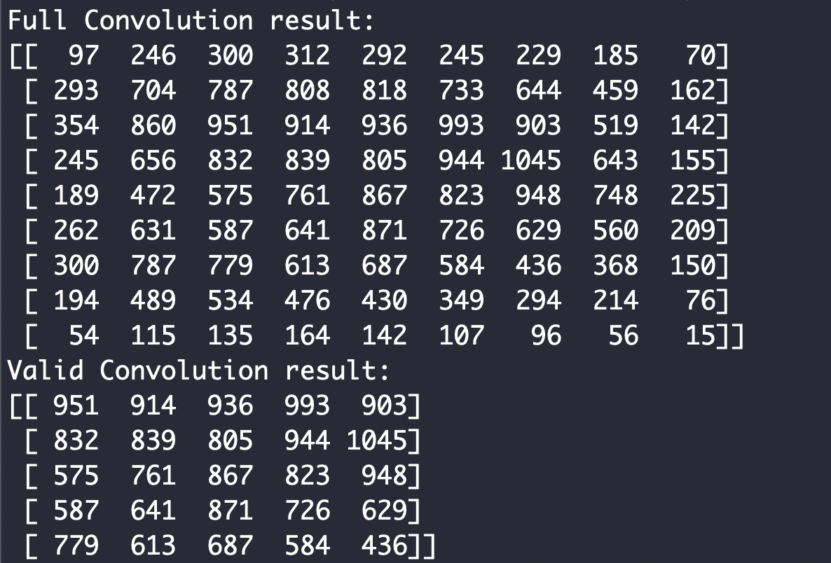

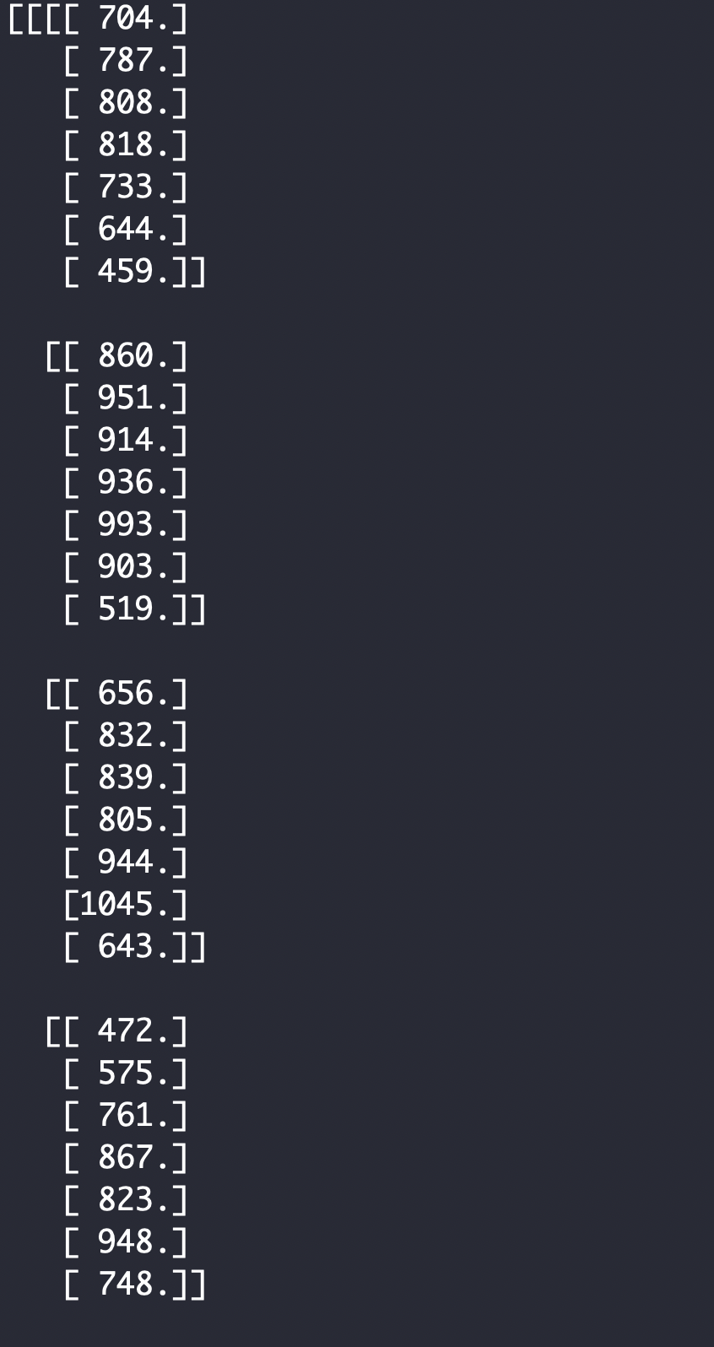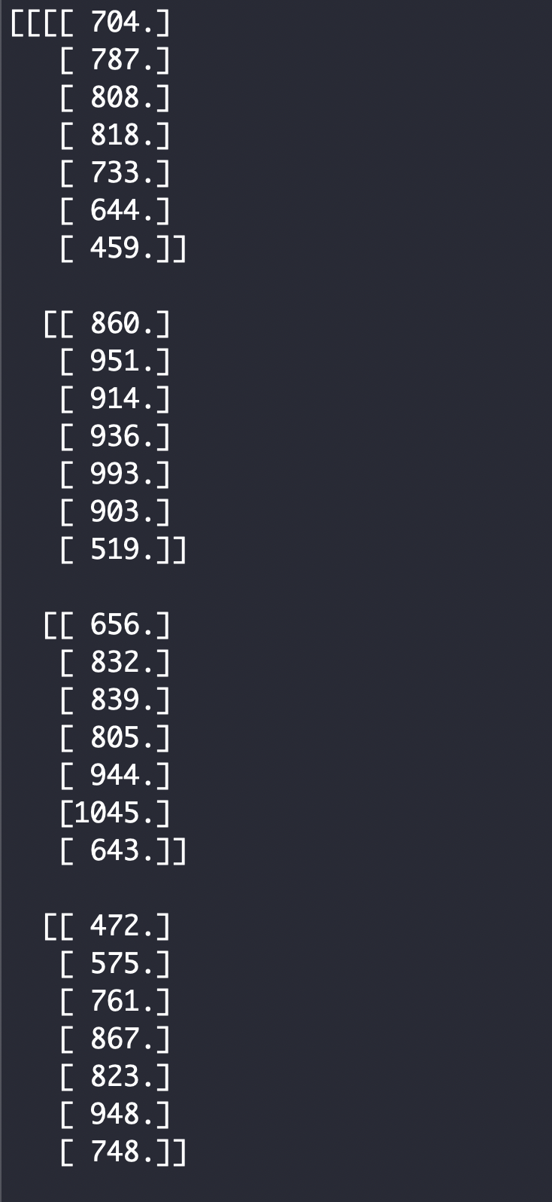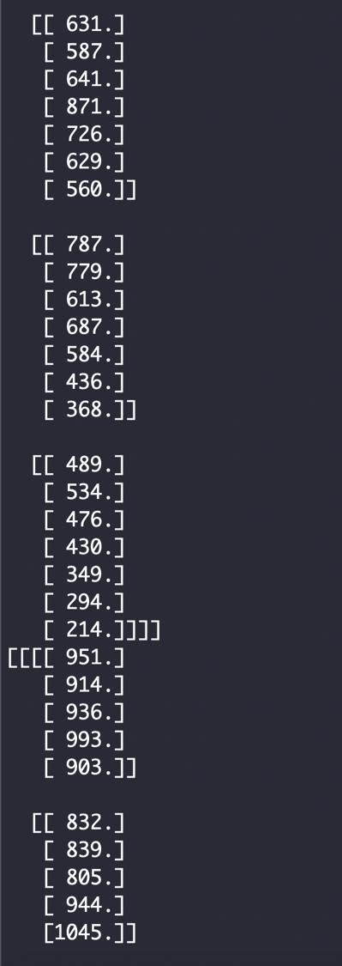

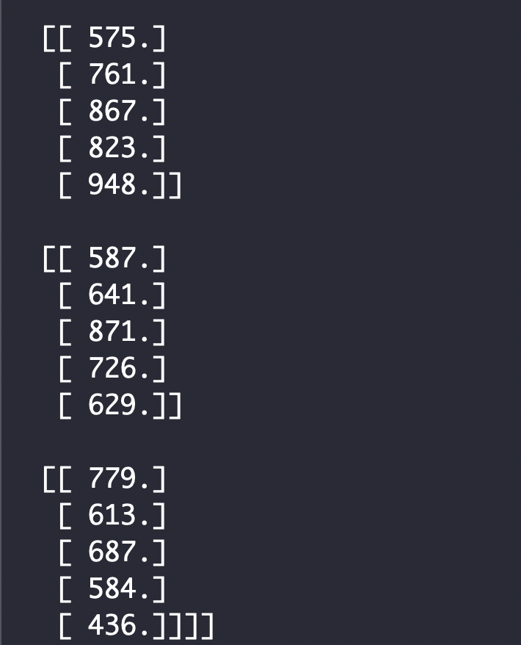

# Problem 2:

'''

Week6 - Problem 2

'''

import numpy as np

from scipy import signal

import matplotlib.pyplot as plt

from PIL import Image

#Read the image

image = Image.open('02Rice.png')

fig, aux = plt.subplots(figsize=(8,8), num='Original figure')

aux.imshow(image, cmap='gray')

plt.show()

plt.waitforbuttonpress()

plt.close()

#Convert to just the Luminance values

image_lum = image.convert('L')

#Get the image as an array

image_arr = np.asarray(image_lum)

#Laplacian filter #1

lap_filter_1 = np.array([[0, 1, 0],

[1, -4, 1],

[0, 1, 0]])

conv_image_1 = signal.convolve2d(image_arr, lap_filter_1, mode='same', boundary='symm')

fig, aux = plt.subplots(figsize=(8,8), num='After applying filter 1')

aux.imshow(np.absolute(conv_image_1), cmap='gray')

plt.show()

plt.waitforbuttonpress()

plt.close()

#Laplacian filter #2

lap_filter_2 = np.array([[1, 1, 1],

[1, -8, 1],

[1, 1, 1]])

conv_image_2 = signal.convolve2d(image_arr, lap_filter_2, mode='same', boundary='symm')

#conv_image_2 = signal.convolve2d(conv_image_1, lap_filter_2, mode='same', boundary='symm')

fig, aux = plt.subplots(figsize=(8,8), num='After applying filter 2')

aux.imshow(np.absolute(conv_image_2), cmap='gray')

plt.show()

plt.waitforbuttonpress()

plt.close()

#Laplacian filter #3

lap_filter_3 = np.array([[0, 1, 0],

[1, -5, 1],

[0, 1, 0]])

conv_image_3 = signal.convolve2d(image_arr, lap_filter_3, mode='same', boundary='symm')

#conv_image_3 = signal.convolve2d(conv_image_2, lap_filter_3, mode='same', boundary='symm')

fig, aux = plt.subplots(figsize=(8,8), num='After applying filter 3')

aux.imshow(np.absolute(conv_image_3), cmap='gray')

plt.show()

plt.waitforbuttonpress()

plt.close()

#Laplacian filter #4

lap_filter_4 = np.array([[1, 1, 1],

[1, -9, 1],

[1, 1, 1]])

conv_image_4 = signal.convolve2d(image_arr, lap_filter_4, mode='same', boundary='symm')

#conv_image_4 = signal.convolve2d(conv_image_3, lap_filter_4, mode='same', boundary='symm')

fig, aux = plt.subplots(figsize=(8,8), num='After applying filter 4')

aux.imshow(np.absolute(conv_image_4), cmap='gray')

plt.show()

plt.waitforbuttonpress()

plt.close()

#Laplacian filter #1 and #2

conv_image_5 = signal.convolve2d(image_arr, lap_filter_1 + lap_filter_2, mode='same', boundary='symm')

fig, aux = plt.subplots(figsize=(8,8), num='After applying filter 1 + 2')

aux.imshow(np.absolute(conv_image_5), cmap='gray')

plt.show()

plt.waitforbuttonpress()

plt.close()

#Laplacian filter #3 and #4

conv_image_6 = signal.convolve2d(image_arr, lap_filter_3 + lap_filter_4, mode='same', boundary='symm')

fig, aux = plt.subplots(figsize=(8,8), num='After applying filter 3 + 4')

aux.imshow(np.absolute(conv_image_6), cmap='gray')

plt.show()

plt.waitforbuttonpress()

plt.close()

#Laplacian filter #1, #2, #3 and #4

conv_image_7 = signal.convolve2d(image_arr, lap_filter_1 + lap_filter_2 + lap_filter_3 + lap_filter_4, mode='same', boundary='symm')

fig, aux = plt.subplots(figsize=(8,8), num='After applying filter 1 + 2 + 3 + 4')

aux.imshow(np.absolute(conv_image_7), cmap='gray')

plt.show()

plt.waitforbuttonpress()

plt.close()

Attaching output applying filters independently, and then Filter1+Filter2, Filter3+Filter4, and then Filter1+Filter2+Filter3+Filter4

**The title of the figure says the filter applied.**

**Original image**

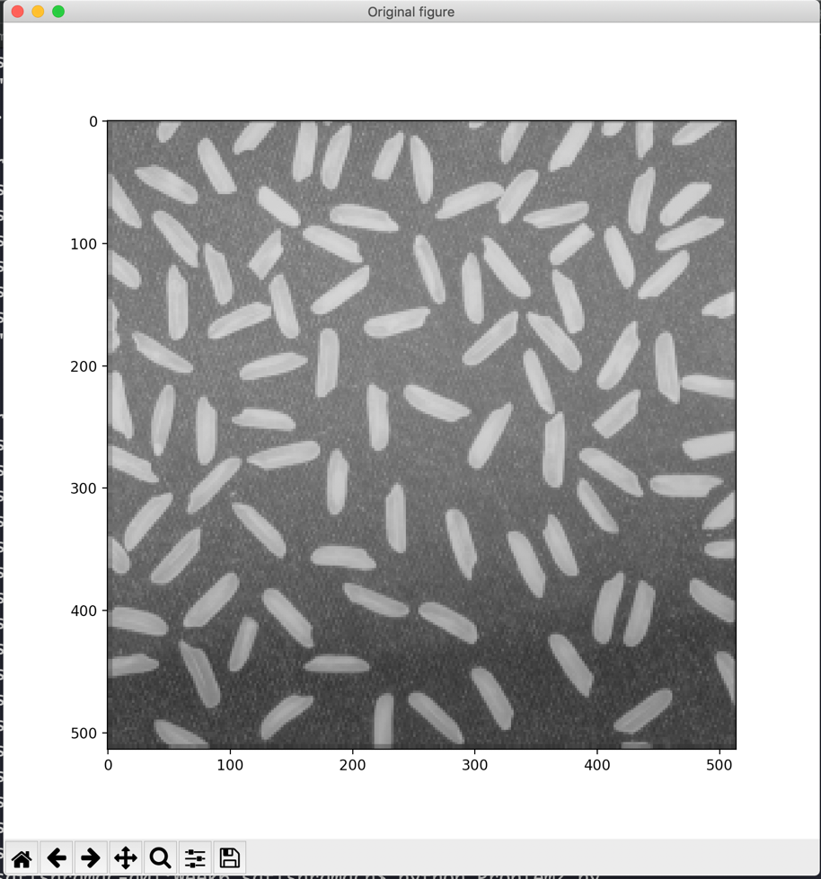

**Filter #1**

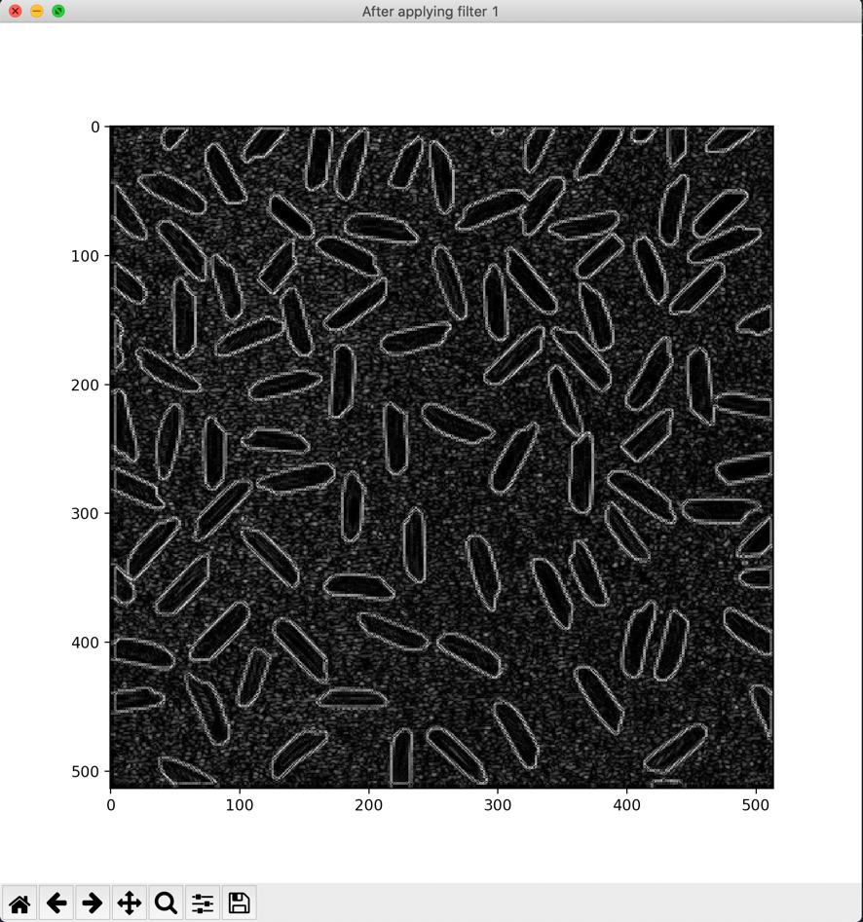

**Filter #2**

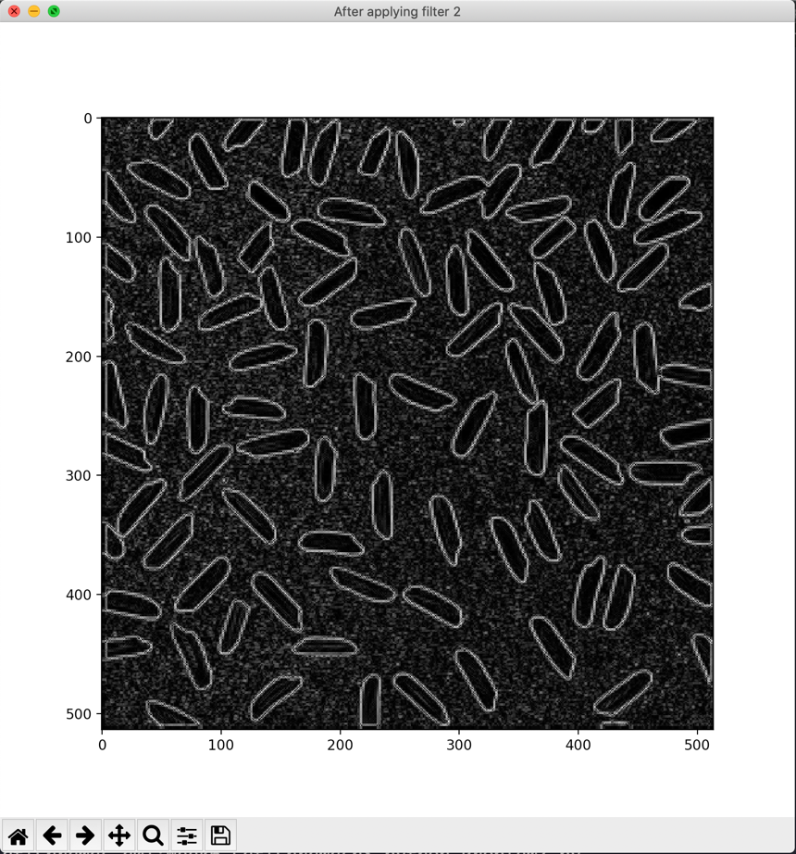

**Filter #3**

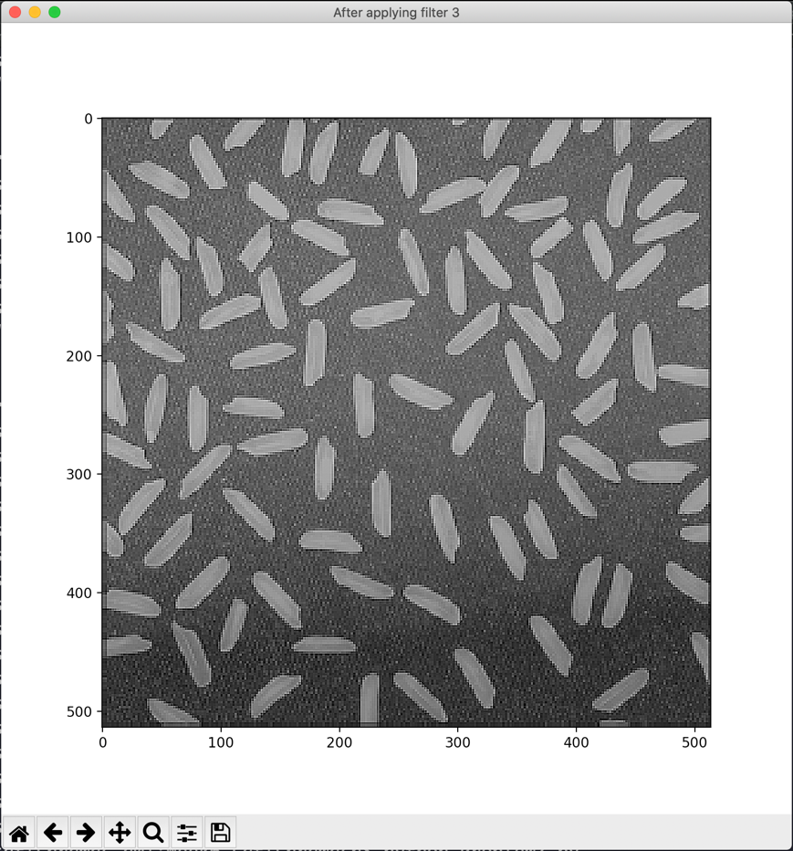

**Filter #4**

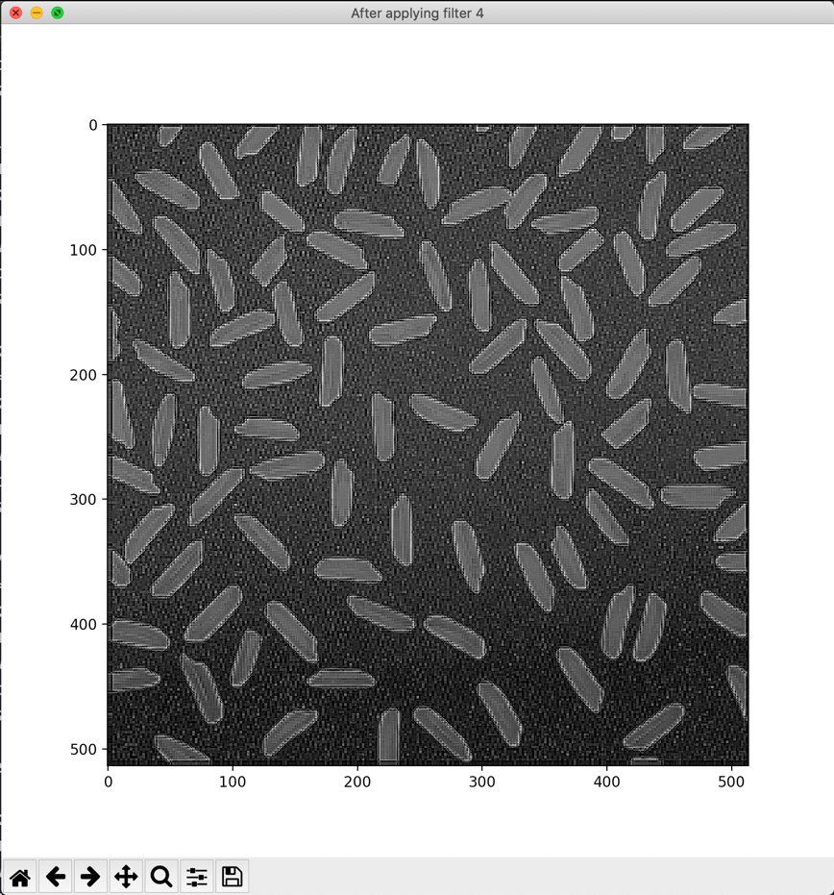

**Applying Filter1 + Filter2**

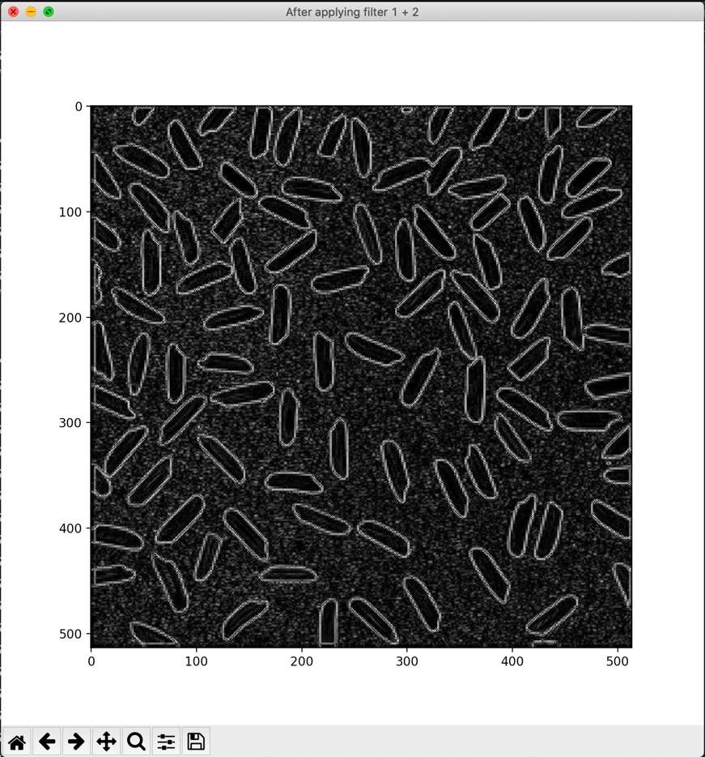

**Applying Filter3 + Filter4**

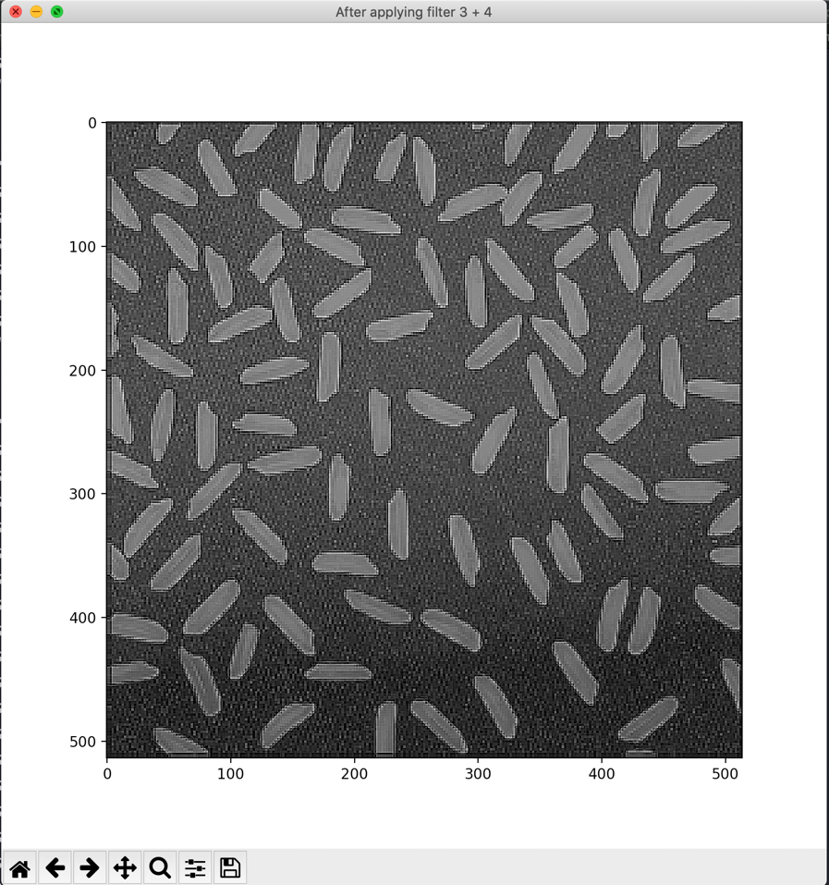

**Applying Filter1 + Filter2 + Filter3 + Filter4**

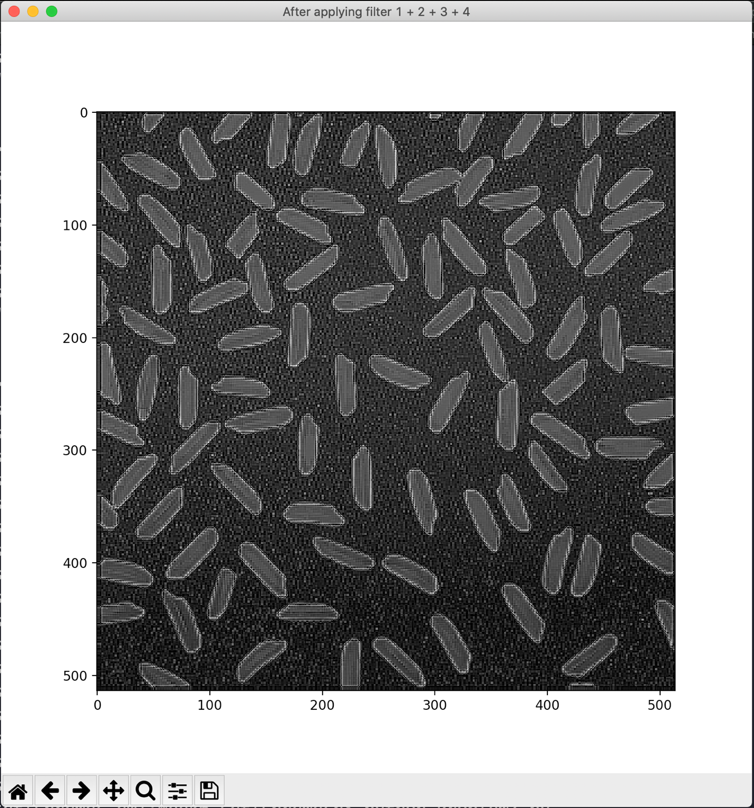

# Problem #3

'''

Week6 - Problem 3

Applying Laplacian, Sobel and Canny filters on an image

'''

import numpy as np

import matplotlib.pyplot as plt

import cv2

#Read the image

image = cv2.imread('02Rice.png', 0)

fig, aux = plt.subplots(figsize=(4,4), num='Original figure')

aux.imshow(image, cmap='gray')

plt.show()

plt.waitforbuttonpress()

plt.close()

#Laplacian filter

laplacian = cv2.Laplacian(image, cv2.CV_64F, ksize=5)

fig, aux = plt.subplots(figsize=(4,4), num='After applying Laplacian filter with size 5')

aux.imshow(laplacian, cmap='gray')

plt.show()

plt.waitforbuttonpress()

plt.close()

#Sobel-x filter

sobelx = cv2.Sobel(image, cv2.CV_64F, 1, 0, ksize=5)

fig, aux = plt.subplots(figsize=(4,4), num='After applying Sobel filter [X - axis] with size 5')

aux.imshow(sobelx, cmap='gray')

plt.show()

plt.waitforbuttonpress()

plt.close()

#Sobel-y filter

sobely = cv2.Sobel(image, cv2.CV_64F, 0, 1, ksize=5)

fig, aux = plt.subplots(figsize=(4,4), num='After applying Sobel filter [Y - axis] with size 5')

aux.imshow(sobely, cmap='gray')

plt.show()

plt.waitforbuttonpress()

plt.close()

#Canny edge filter

canny = cv2.Canny(image, 50,200)

fig, aux = plt.subplots(figsize=(4,4), num='After applying Canny edge detector filte')

aux.imshow(canny, cmap='gray')

plt.show()

plt.waitforbuttonpress()

plt.close()

The output is captured in the images. The title of the image shows the filter that has been applied.

